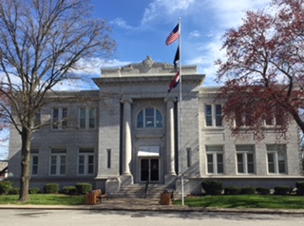 | Barry County Clerk  Joyce Ennis  700 Main, Suite 2  Cassville MO 65625  Phone: 417-847-2561 ext. 3  Fax: 417-847-5311  Email: jennis@barrycountyclerk.com

November 29, 2023

News Release:

The Barry County Clerk’s office would like to announce Polling location changes. The changes will begin with the April 2, 2024 election.

- Cassville Rural/Mineral voters will merge with Cassville City and vote at the Family Life Center located at 200 E. 5th Street, Cassville MO

- Exeter voting will move from the fire station to the Exeter Community Building, 112 S Front Street, Exeter MO

- Monett Rural/Capps Creek voters will merge with Monette City and vote at the Monett City Park Casino building.

All Barry County voters will be receiving new voter ID cards in January 2024. Voter ID cards list polling location, and special districts (fire, road, etc.) specific to each voter.

For questions or concerns please contact the County Clerk’s office at 417-847-2561 or email; jennis@barrycountyclerk.com

